INSTITUTIONAL QUALITY ASSUARANCE CELL (IQAC)
Self-assessment Committee of Department of Pharmacy

Head | Designation | Contacts
Dr. Mir Imam Ibne Wahed | Professor & Chairman | wahed_mir@ru.ac.bd | 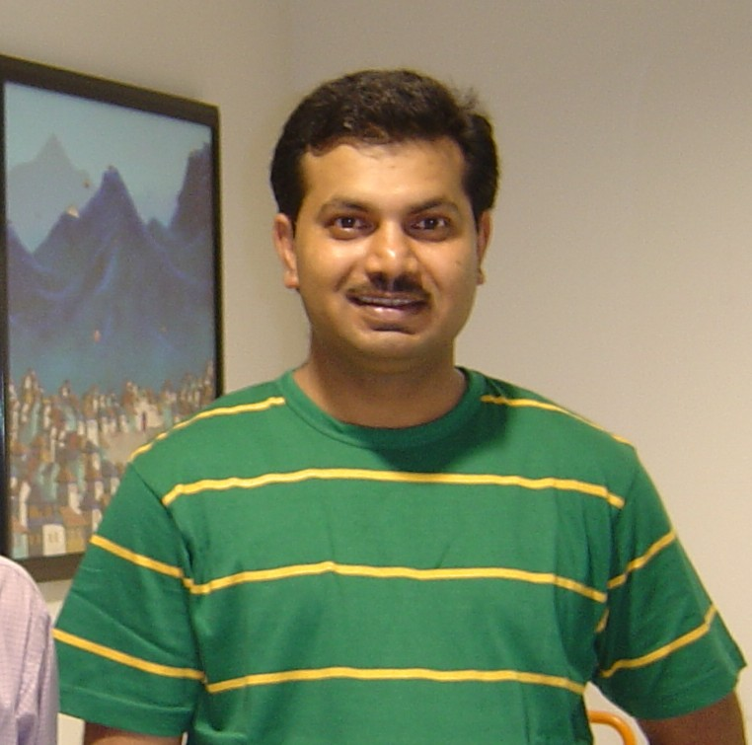
Member
1. Dr. Md. Aziz Abdur Rahman | Professor | aziz2002@asia.com | 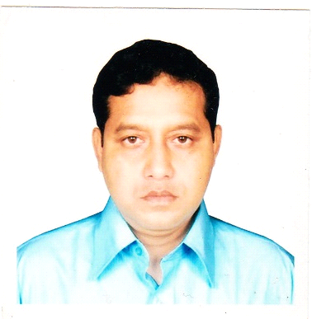
2. Dr. Md. Aktaruzzaman Chowdhury | Professor | auchow5@yahoo.com | 