Evening MBA Program - 2025
Semester: January-June, 2025
Brochure
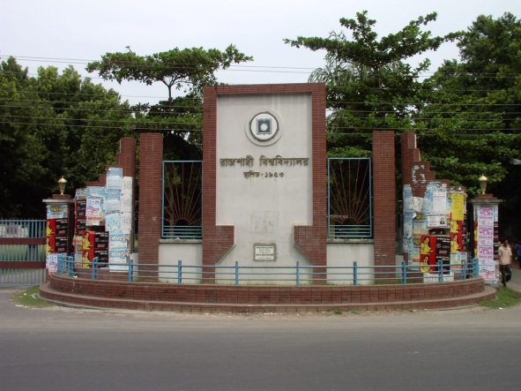

Faculty of Business Studies

Department of Marketing

University of Rajshahi
Bangladesh

INTRODUCTION

The Evening MBA is an up-to-date and well equipped graduate program dedicated to produce quality executives to meet the ongoing challenges in the global competitive environment. The University of Rajshahi introduced the Evening MBA Program under the Faculty of Business Studies to respond to the growing demand of skilled human resources in the country. The program involves about 28 highly qualified faculty members educated from reputed universities of home and abroad.

APPLICATION FORMALITIES
Candidates will collect the application form along with instruction papers from the office of the Chairman, Department of Marketing during the office hours from 9.00 am to 3:00 pm. Application fee of Tk. 500.00 (Non - refundable) is required to be paid in cash in favor of the Chairman, Department of Marketing, University of Rajshahi.

SCHEDULE
Submission of Application Form | : 12-12-2019
Admission Test | : 13-12-2019, Time: 11.30am
Interview | : 13-12-2019, Time: 3.00pm
Result Notification | : 13-12-2019, Time: 5.00pm

ADMISSION REQUIREMENT
Graduates from any discipline can apply. The candidate’s eligibility will be judged on the basis of their previous academic records. Applicants must have minimum 6 (Six) points in their academic attainment calculated as below:
Name of Degrees | 1st Div / Class/  GPA 3.50 & above | 2nd Div / Class /GPA 3.00> 3.50 | 3rd Div / Class /GPA 2.25 > 3.00
SSC | 3 | 2 | 1
HSC | 3 | 2 | 1
Bachelor ( Pass ) | 5 | 3 | 2
Bachelor ( Hons ) | 5 | 4 | 2
Masters | 1 | 1 | 1

Applicants with more than one third division/class in academic career shall not be considered.

ADMISSION TEST INFORMATION
Applicants seeking enrollment into the Evening MBA Program are required to sit for an MCQ type Admission Test of 50 marks covering following subjects:
- English - 20 ( Paragraph, Translation and Grammar )
- General Knowledge– 30 ( General Affairs, General Mathematics & IQ )

PROGRAM FEE
Total program fee is Tk. 1,00,000/- (One Lac), which will cover entire academic & administrative expenses payable in four installments amounting Tk. 32,000/-, (Course Fee 30,000/- + Form Fill up Fee 500/- (for all Semester) + Application Fee 500/- + Development Fund 1000/-) 30,500/-, 20,500/- and 20,500/- respectively over four semesters.

ACADEMIC YEAR AND SEMESTER
The duration of the program is 2 (two) academic years divided into four semesters. Two semesters will be conducted in a year.
In each semester students are allowed to take maximum 5 (five) courses but minimum 2 (two) courses. The entire program must be completed within 5 (five) academic years.

CURRICULUM
The Evening MBA Program comprises 20 (twenty) courses consisting of 15 (fifteen) prerequisite courses and 5 (five) specialized courses. Total marks in each course shall be distributed in percentage as follows:

Particulars | Percentage
Class attendance | 10%
Mid-term test | 20%
Case analysis & presentation | 10%
Term paper/Assignment | 10%
Final examination | 50%
Total | 100%

DEGREE REQUIREMENTS AND AWARD OF DEGREE
The Evening MBA Program shall be of 66 (sixty six) credit hours of which 60 (sixty) for course work, 3 (three) for internship and 3(three) for viva voce.
The students shall be awarded the degree by the University of Rajshahi on the recommendation of the Departmental Academic Committee. The students completing the academic requirements with the minimum CGPA of 2 (two) will be eligible for the degree.

GRADING SYSTEM
The total marks in a course in a secured by a student shall be converted into letter grades and grade points as:
Percentage Range | Letter Grade | Grade Point
80 & above | A+ | 4.00
75- less than 80 | A | 3.75
70- less than 75 | A - | 3.50
65- less than 70 | B+ | 3.25
60- less than 65 | B | 3.00
55- less than 60 | B- | 2.75
50- less than 55 | C+ | 2.50
45- less than 50 | C | 2.25
40- less than 45 | D | 2.00
Less than 40 | F | 0.00

FACILITIES FOR STUDENTS
Class rooms are well furnished and fully air-conditioned.
Well furnished and well equipped computer lab open for evening MBA students.
Purified drinking water available for students.

FOR FURTHER ENQUIRY PLEASE CONTACT
Telephone : 0721-711135/ Ext. 101-103
Mobile : 01788-814265
Fax : 0721- 750064

