GRADING SYSTEM
The total marks in a course are secured by a student shall be converted into letter grades and grade points as:

Percentage Range | Letter Grade | Grade Point
80 & above | A+ | 4.00
75- less than 80 | A | 3.75
70- less than 75 | A - | 3.50
65- less than 70 | B+ | 3.25
60- less than 65 | B | 3.00
55- less than 60 | B- | 2.75
50- less than 55 | C+ | 2.50
45- less than 50 | C | 2.25
40- less than 45 | D | 2.00
Less than 40 | F | 0.00

FACILITIES FOR STUDENTS
- Class rooms are well furnished and fully air-conditioned.
- Well-furnished and well equipped computer lab open for all EMBA students.
- Purified drinking water available for students.

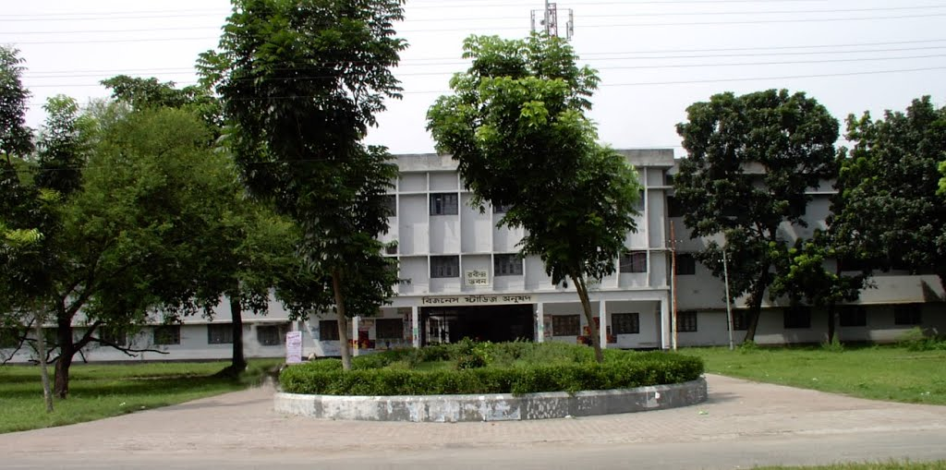
FOR FURTHER ENQUIRY PLEASE CONTACT
Telephone : 0721-711135/ Ext. 101-103
Mobile : 01788-814265, 01914-254162, 01716-077780
Fax : 0721- 750064

4
EMBA Program – 2025

For Business Graduates

Semester: January-June, 2025

Brochure
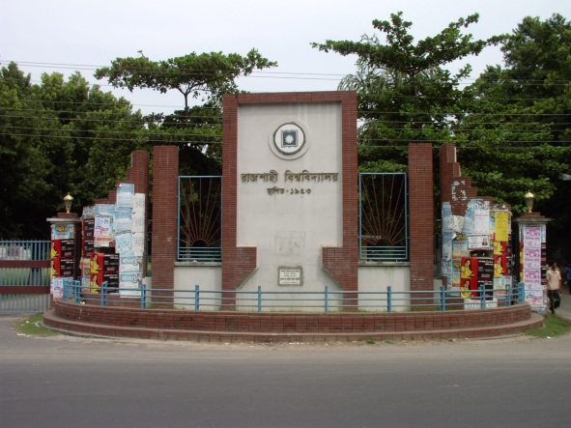

Faculty of Business Studies

Department of Marketing

University of Rajshahi
Bangladesh

INTRODUCTION

The EMBA for Business Graduates is an up-to-date and well equipped graduate program dedicated to produce quality executives to meet the ongoing challenges in the global competitive environment. The University of Rajshahi introduced EMBA for Business Graduate Program under the Faculty of Business Studies to respond to the growing demand of skilled human resources in the country. The program involves about 24 highly qualified faculty members educated from reputed universities of home and abroad.

APPLICATION FORMALITIES
Candidates will have to collect the application form along with instruction papers from the office of the Chairman, Department of Marketing during the office hours from 9:00 am to 3:00 pm. The Application fee is Tk. 500.00 (Non-refundable) is required to be paid in cash. The Applicant can also download application from and brochure the website http://www.ru.ac.bd/marketing/notices/

SCHEDULE
Submission of Application Form | : 12-12-2019
Admission Test | : 13-12-2019, Time: 11.30am
Interview | : 13-12-2019, Time: 3.00pm
Result Notification | : 13-12-2019, Time: 5.00pm

ADMISSION REQUIREMENT
Students who have completed 4 years BBA, BBS, BBS (Hons) etc. are eligible to apply. The candidate’s eligibility will be judged on the basis of their previous academic records. Applicants must have minimum 6 (Six) points in their academic attainment calculated as below:
Name of Degrees | 1st Div / Class/  GPA 3.50 & above | 2nd Div / Class /GPA 3.00> 3.50 | 3rd Div / below 3.00
SSC | 3 | 2 | 1
HSC | 3 | 2 | 1
Bachelor (4 Years ) | 5 | 4 | 3

N.B. Applicants with no more than one third division/class/GPA below 2.50 in academic career shall not be considered.

ADMISSION TEST INFORMATION
Applicants seeking enrollment into the For Business Graduates EMBA Program are required to sit for MCQ type Admission Test of 50 marks covering following subjects:
- English - 15
- General Knowledge & IQ – 15 [General Affairs, General Mathematics & IQ]
- General Business – 20 [Marketing, Finance, Accounting, Management, and Economics]

PROGRAM FEE
Total program fee is Tk. 75,000.00 (Seventy Five Thousand), which will cover entire academic & administrative expenses payable in two installments amounting
Tk. 42,000/- (Course Fee 40,000/- + Form Fill up Fee 500/- + Application Fee 500/- + Development Fund 1000/-) For 1st Semester and 35,500/- For 2nd Semester respectively over two semesters.

ACADEMIC YEAR AND SEMESTER
The duration of the program is one academic year divided into two semesters. Two semesters will be conducted in a year having 5 (five) courses in each semester.

CURRICULUM
The EMBA for Business Graduates Program comprises 10 (ten) courses consisting of 5 (five) prerequisite courses and 5 (five) specialized courses. Total marks in each course shall be distributed in percentage as follows:

Particulars | Percentage
Class attendance | 10%
Mid-term test | 20%
Case analysis & presentation | 10%
Term paper/ Assignments | 10%
Final examination | 50%
Total | 100%

REQUIREMENTS AND AWARD OF DEGREE
The EMBA for Business Graduates shall be of 36 (thirty six) credit hours of which 30 (thirty) for course work, 3 (three) for internship and 3(three) for viva voce.
The students shall be awarded the degree by the University of Rajshahi on the recommendation of the Departmental Academic Committee. The students completing the academic requirements with the minimum CGPA of 2 (two) will be eligible for the degree.

